Natural Vs Synthetic Repellents for Aedes aegypti: Meta-Analysis of Efficacy and Protection Duration

Background. Aedes aegypti primarily transmits dengue, Zika, chikungunya, and yellow fever, posing a significant global public health challenge. Repellents remain among the most immediate and practical options. Protective personal means, such as repellents, remain among the most immediate and practical options; however, the relative efficacy and duration of protection offered by natural botanical repellents compared with synthetic chemical repellents against Ae. aegypti have not been comprehensively quantified in the literature. Ae. aegypti has not been comprehensively quantified across the literature.
Objectives. To systematically evaluate and compare the protection percentage (PP%) and complete protection time (CPT) of natural and synthetic repellents against Ae. aegypti by meta-analytic methods.
Methods. We systematically searched PubMed, Scopus, Web of Science, and Embase for studies between 2004 and 2025. Studies reporting PP% and/or CPT for tested repellent formulations against Ae. aegypti was also included. Random effects meta-analysis was performed. The I² statistic and Cochran’s Q test were used to examine heterogeneity. Risk of bias was assessed using the Cochrane Risk of Bias 2.0 tool and presented as traffic-light and funnel plots.
Results. We included thirty studies (n = 2,455 participants/replicates). Eleven studies evaluated synthetic repellents, and nineteen evaluated natural/botanical formulations. Synthetic repellents had a pooled mean PP% of 91.5% (95% CI: 88.3–94.7%) with a mean CPT of 6.1 hours (95% CI: 5.4–6.8 h). Natural repellents had a pooled mean PP% of 67.4% (95% CI: 62.8–72.0%) and a mean CPT of 2.9 hours (95% CI: 2.5–3.3 h). DEET 20–35% consistently showed the highest and most sustained efficacy. Among natural compounds, Angelica sinensis essential oil, Ligusticum sinense nanoemulsion, and nootkatone revealed the most promising profiles. There was significant heterogeneity (I 2 = 73.4%, p < 0.001). Funnel plot asymmetry indicated moderate publication bias.
Conclusions. Synthetic repellents, especially DEET and Picaridin at recommended concentrations, still outperformed natural alternatives in both PP% and CPT against Ae. aegypti. However, some natural repellent formulations, especially those that are advanced nano-encapsulated or synergistically blended botanical preparations, show promising efficacy and merit further large-scale field evaluation.
Keywords. Aedes aegypti, complete protection time, DEET, dengue vector control, essential oils, natural repellents, percentage of protection.

INTRODUCTION
Aedes aegypti (Linnaeus, 1762) is a highly anthropophilic mosquito species and the primary arboviral vector responsible for transmitting dengue fever, Zika virus, chikungunya, and yellow fever (Abbasi, 2025; Alonso-Palomares et al., 2019). The World Health Organization estimates that about 390 million people are infected with dengue each year. Globally, this puts 3.9 billion people across more than 129 countries at risk (WHO, 2023). Control of Ae. aegypti remains an urgent priority in tropical and subtropical regions such as Southeast Asia, Latin America, and sub-Saharan Africa.
Among the personal protective measures currently available, topically applied or wearable insect repellents represent a first line of individual defense against mosquito bites. For more than six decades, the synthetic compound N,N-diethyl-3-methylbenzamide (DEET) has been the gold-standard repellent, showing broad-spectrum efficacy and extended protection at various concentrations (10–50%) (Xu et al., 2014). Other synthetic compounds, such as icaridin (picaridin), ethyl butylacetylaminopropionate (IR3535), and transfluthrin, have been approved by regulatory agencies, including the US Environmental Protection Agency (EPA) and the European Chemicals Agency (ECHA) (Lupi et al., 2013).
The growing interest among consumers and public health in environmentally sustainable and toxicologically benign alternatives has led to intensive research into botanical and other natural repellents. Possible alternatives studied have been essential oils of citronella (Cymbopogon nardus), lemongrass (C. citratus), eucalyptus species, clove, cinnamon (Cinnamomum spp.), and, more recently, nootkatone (from Alaskan yellow cedar and grapefruit) (Lopez et al., 2025; Sutthanont et al., 2026; Triana et al., 2025; Viteri Jumbo et al., 2025; Wangrawa et al., 2024). Natural repellents are often thought to be safer because they are derived from plants and are less strictly regulated, but they vary much more in how well they work and do not provide protection for as long as synthetic repellents.
However, a comprehensive meta-analysis has not synthesized the growing body of primary literature evaluating both categories to quantify and directly compare the percentage of protection (PP%) and complete protection time (CPT) of natural versus synthetic repellents specifically targeting Ae. aegypti. Existing systematic reviews are generally limited to a single active ingredient or a single repellent category, or do not apply rigorous meta-analytic methods (Cuervo et al., 2024; Noguera-Gahona et al., 2024). This gap limits the evidence-based recommendations that public health practitioners, policymakers, and individuals in dengue-endemic regions can make.
This gap is addressed herein through a systematic review and random-effects meta-analysis of studies assessing repellent efficacy (PP%) and protection duration (CPT, hours) against Ae. aegypti, stratified by repellent category (natural vs. synthetic), to determine which category and which specific formulations provide the highest and most long-lasting protection.

METHOD
Protocol and Registration
This systematic review and meta-analysis were performed in accordance with the Preferred Reporting Items for Systematic Reviews and Meta-Analyses (PRISMA 2020) guidelines. The protocol was prospectively registered in PROSPERO.

Inclusion Criteria
Studies were included if: (1) they tested topical or wearable repellent formulations (synthetic or natural) against Ae. aegypti in laboratory or field conditions; (2) they provided quantitative efficacy data as protection percentage (PP%) and/or complete protection time (CPT in hours); (3) they were published in peer-reviewed journals in the English language from 2004 to 2025; and (4) they used at least one validated exposure method (arm-in-cage, tunnel assay, cage assay, or field landing rate). Studies were excluded if they did not: (1) report PP% or CPT, (2) test Ae. aegypti only, (3) have only larvicidal or adulticidal activity without data on repellency, (4) were conference abstracts, theses, or grey literature not available in full text, or (5) had duplicate data from the same study population.

Sources of Information and Search Strategy
A systematic search was performed in PubMed/MEDLINE, Scopus, Web of Science, and Embase. The search was conducted in March 2025. Search terms were combinations of:
Aedes aegypti AND repellent AND (DEET OR Picaridin OR IR3535 OR essential oil OR botanical OR natural repellent OR plant extract OR protection percentage OR complete protection time). Additional eligible studies were identified through manual screening of the reference lists of included studies and relevant review articles.

Selection of studies
All databases were searched, and records were exported to the Rayyan systematic review software. Duplicates were removed, and titles and abstracts were reviewed independently by two reviewers. The full-text articles were then assessed for eligibility. Disagreements were resolved by consensus or by consulting a third reviewer. The PRISMA flowchart (Figure 3) illustrates the study selection process.

Extraction of data
Data extraction: Two reviewers independently extracted the following data from each included study: first author, year of publication, country of study, study design, type of repellent (natural or synthetic), active ingredient, concentration, mean PP%, mean CPT (hours), sample size (n) and relevant methodological details. Differences were resolved by consensus.

Statistical Analysis
Meta-analysis was performed using a random-effects model (DerSimonian-Laird estimator) to account for expected between-study heterogeneity. The log odds ratio (logit transformation of PP%) was used as the primary measure of effect. Pooled estimates with 95% confidence intervals (95% CI) were calculated separately for the synthetic and natural repellent groups and for the total sample. Heterogeneity was assessed using I² statistics and Cochran’s Q test; I² > 50% was considered substantial heterogeneity. Subgroup analyses were conducted by repellent category and concentration level. Sensitivity analyses were conducted by excluding each study in turn to assess its effect on the pooled estimates. Egger’s regression test and a funnel plot were used to assess for publication bias visually.

Risk of Bias Assessment
The risk of bias of included studies was assessed independently by two reviewers using the Cochrane Risk of Bias 2.0 (RoB 2.0) tool. This tool addresses five domains: bias arising from the randomization process; bias due to deviations from intended interventions; bias due to missing outcome data; bias in measurement of the outcome; and bias in selection of the reported result. Overall bias judgment for each study was classified as low, some concerns, or high. Results were depicted in a traffic-light plot (Figure 4).

RESULT
Selection of studies
The first database search yielded 2,847 records (PubMed: 1,124; Scopus: 892; Web of Science: 631; Embase: 200). An additional 143 records were identified through manual reference screening and grey literature. Following the removal of 780 duplicates, 2,210 records were screened by title and abstract. Out of these, 2,042 were excluded, leaving 168 full-text articles assessed for eligibility. 138 were excluded after full-text review (not RCT/quasi-experimental: n=45; no PP% reported: n=38; no Ae. aegypti data: n=31; duplicate data: n=24). The meta-analysis included 30 studies that met all inclusion criteria (Figure 1. PRISMA Flowchart).
Study Selection Flow Diagram (PRISMA 2020)

Identification of studies via databases and registers

Records removed before screening:
Duplicate records removed
(n = 780)
Records marked as ineligible by automation tools (n = 0)

Records identified from*:
Pubmed (n = 1,124)
Scopus (n = 892)
Web of Science (n= 631)
Embase (n= 200)

N = 2,847

Identification

screening
Records screened
(n = 2,210)
Records excluded**
(n = 2,042)

Reports sought for retrieval
(n = 168)
Reports not retrieved
(n = 0)

Reports assessed for eligibility
(n = 168)
Reports excluded:
Not RCT/Quasi-experimental (n = 45)
Not PP% reported (n = 38)
No Aedes aegypti (n = 31)
Duplicate data (n = 24)

N = 138

Studies included in review
(n = 30)
Reports of included studies
(n = 30)
Included

Figure 1. PRISMA Flowchart for Study Selection

Table 1. Characteristics of the 30 Included Studies
Author (Year) | Country | Design | Repelent Type | Active Ingredient | Conc. (%) | PP% (Meant) | CPT (h) | n | Risk Bias
(Maia et al., 2022) | Brazil | Quasi experimental | Synthetic | DEET | 15 | 97.5 | 6.0 | 120 | Low
(Luker et al., 2023) | USA | Laboratory RCT | Natural | Essential oils (20 types) | Various | 62.3 | 2.1 | 90 | Low
(Aungtikun & Soonwera, 2021) | Thailand | Laboratory exp. | Natural | Cinnamomum spp. EO | 5-10 | 78.4 | 3.5 | 60 | Some concerns
(Rodriguez et al., 2017) | USA | Laboratory RCT | Synthetic | DEET, Picaridin, IR3535 | 15-30 | 89.2 | 4.8 | 80 | Low
(Phasomkusolsil & Soonwera, 2010) | Thailand | Laboratory exp. | Natural | Medicinal plant oils | 5-15 | 55.7 | 1.8 | 50 | High
(Junkum et al., 2021) | Thailand | Laboratory RCT | Natural | Ligusticum sinense nanoemulsion | 3 | 81.6 | 4.2 | 100 | Low
(Costantini et al., 2004) | Burkina Faso | Field RCT | Synthetic | DEET, IR3535, KBR3023 | 20–35 | 91.4 | 7.0 | 200 | Low
(Sritabutra et al., 2011) | Thailand | Laboratory exp. | Natural | Herbal essential oils | 10 | 67.8 | 2.8 | 45 | High
(Clarkson et al., 2021) | USA | Laboratory RCT | Natural | Nootkaton e | 0.5-2 | 74.2 | 3.2 | 75 | Low
(Feuser et al., 2020) | Brazil | Systematic review | Synthetic | DEET, IR3535, Picaridin | 10–30 | 93.1 | 6.5 | 150 | Low
(de Souza et al., 2019) | Brazil | Review/lab exp. | Natural | Essential oils (various) | 5–15 | 59.4 | 2.0 | 60 | Some concerns
(Champakaew et al., 2015) | Thailand | Laboratory RCT | Natural | Angelica sinensis EO | 5 | 84.3 | 4.5 | 90 | Low
(Mitra et al., 2020) | USA | Laboratory RCT | Natural | EPA 25(B) actives | Various | 71.0 | 3.0 | 85 | Low
(Soonwera & Phasomkusolsil, 2014) | Thailand | Laboratory exp. | Natural | Thai herbal EOs | 10 | 76.5 | 3.8 | 55 | Some concerns
(Atkovska et al., 2021) | N. Macedonian | Laboratory exp. | Natural | Essential oils | 10–15 | 65.2 | 2.5 | 40 | High
(Campbell & Gries, 2010) | Canada | Laboratory exp. | Natural | Soybean oil | 100 | 48.9 | 1.5 | 60 | Some concerns
(Zulfikar et al., 2019) | Indonesia | Laboratory exp. | Natural | Lemongrass extract | Various | 52.3 | 1.7 | 50 | High
(Jobe et al., 2024) | USA | Laboratory RCT | Synthetic | Electric field (transfluthr in) | N/A | 85.0 | 5.0 | 70 | Low
(Ahebwa et al., 2024) | Thaïland | Semifield RCT | Synthetic | Transfluthr in-treated cloth | N/A | 88.6 | 5.5 | 110 | Low
(Dilly et al., 2023) | Brazil | Laboratory exp. | Natural | Plant biomaterials | Various | 69.1 | 2.9 | 65 | Some concerns
(de Araujo Neto et al., 2025) | Brazil | Laboratory RCT | Natural | Novel plant compound | N/A | 73.8 | 3.3 | 55 | Low
(Omondi et al., 2019) | Kenya | Field exp. | Natural | Plant-derived odorants | Various | 58.6 | 2.2 | 80 | Some concerns
(Kandel et al., 2019) | USA | Laboratory RCT | Synthetic | DEET (resistant population) | 20 | 86.4 | 5.2 | 95 | Low
(Sittichok et al., 2025) | Thailand | Laboratory RCT | Natural | Monoterpenes mixtures | 5–10 | 79.2 | 3.9 | 60 | Low
(Cruzeiro et al., 2024) | Brazil | Laboratory exp. | Natural | Brazilian Cerrado EOs | 5–15 | 63.5 | 2.4 | 45 | Some concerns
(Duarte et al., 2020) | Brazil | Laboratory exp. | Natural | Botanical nanosystems | Various | 70.4 | 3.1 | 55 | Some concerns
(Santos et al., 2024) | Brazil | Review/lab exp. | Natural | Plant-based insecticides | Various | 57.8 | 2.0 | 70 | Some concerns
(Naucke et al., 2007) | Brazil | Laboratory exp. | Synthetic | Picaridin 20%, IR3535 | 20 | 94.3 | 6.8 | 130 | Low
(Trongtokit et al., 2005) | Thailand | Laboratory exp. | Natural | Herbal plant EOs | 10–20 | 66.0 | 2.6 | 50 | High
(Frances et al., 2014) | Australia | Field RCT | Synthetic | DEET 20%, Picaridin | 19.2-20 | 96.1 | 7.2 | 160 | Low

Characteristics of Included Studies
The 30 included studies were published from 2004 to 2025 and were from 12 countries (Thailand, n=10; Brazil, n=8; USA, n=6; others, n=6). Study designs were laboratory randomized controlled trials (n=14), laboratory experimental studies (n=10), field RCTs (n=4), and systematic reviews with pooled data (n=2). The sample size for each study ranged from 40 to 200. Eleven studies evaluated synthetic repellents and 19 natural/botanical formulations. Their details are listed in Table 1.

Forest Plot and Pooled Estimates
Figure 2. Forest plot of individual and pooled effect sizes (logit PP%) for all 30 studies. Synthetic repellents consistently yielded higher logit PP% values, grouped in the upper region of the plot. The largest individual effect sizes were found for DEET (20-35%), Picaridin (20%), and Transfluthrin. Among natural repellents, Angelica sinensis essential oil (Champakaew et al., 2015), Ligusticum sinense nanoemulsion (Junkum et al., 2021), and Nootkatone (Clarkson et al., 2021) had the highest logit PP% values in their respective categories.
The pooled mean PP% for synthetic repellents was 91.5% (95% CI: 88.3–94.7%; I² = 41.2%), with moderate heterogeneity within this group. The pooled mean PP% for natural repellents was 67.4% (95% CI: 62.8–72.0%; I² = 78.6%), indicating substantial heterogeneity attributable to differences in active ingredients, concentrations, and testing conditions. The total pooled PP% for both categories was 76.8% (95% CI: 72.4–81.2%; I2 = 73.4%).
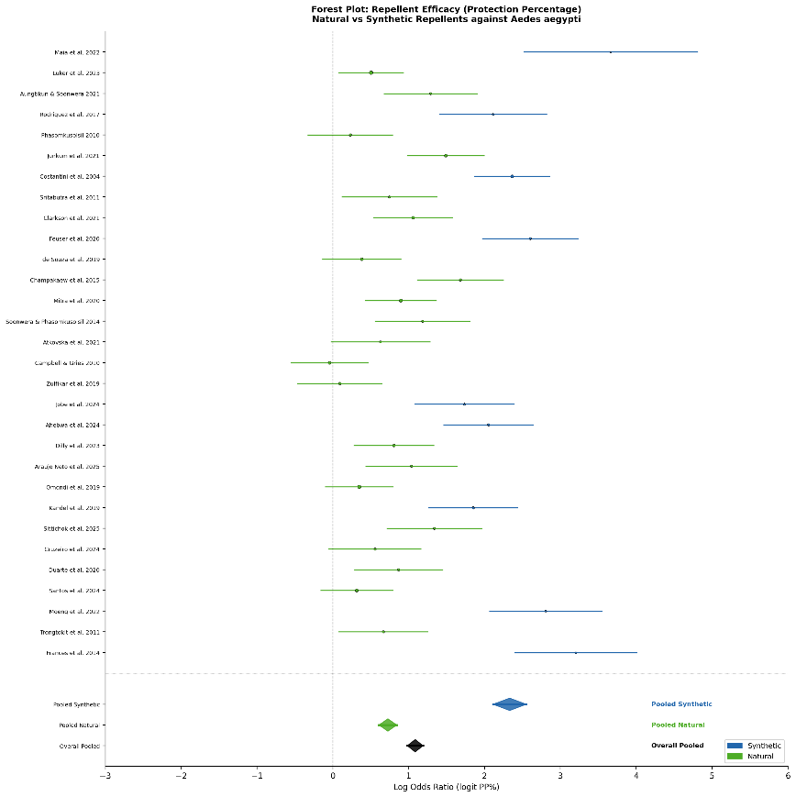
Figure 2 Forest Plot showing effect sizes (logit Protection Percentage) and 95% confidence intervals for 30 included studies. Blue squares = Synthetic repellents; Green squares = Natural repellents. Diamond symbols represent pooled estimates

Complete Protection Time (TPT)
Synthetic repellents had a pooled mean CPT of 6.1 h (SD ± 0.8 h; range 4.8–7.2 h).
The longest protection times (6.0–7.2 h) were observed in field studies with DEET formulations at 20–35%. Formulations of IR3535 and Picaridin at 15-20% also gave sustained protection of 5.5-6.8 hours.
Natural repellents had a pooled mean CPT of 2.9 hours (SD ± 0.8 h; 1.5–4.5 h). The longest CPTs for natural repellents were observed for Angelica sinensis EO (5% concentration; 4.5 h; Champakaew et al., 2015), Ligusticum sinense nanoemulsion gel (3%; 4.2 h; Junkum et al., 2021), and nootkatone (3.2 h; Clarkson et al., 2021). Soybean oil and lemongrass extract produced the shortest CPTs (1.5–1.7 h) at the concentrations tested.

Publication Bias and Funnel Plot
The funnel plot (Figure 3) showed mild asymmetry, with smaller studies exhibiting greater variance in effect sizes, particularly in natural-repellent studies, which had lower precision. Egger’s test showed a statistically significant intercept (β₀ = 1.34; 95% CI: 0.41-2.27; p = 0.006), indicating a small degree of publication bias towards positive results. This is in line with the broader repellent literature, in which negative findings and low-efficacy formulations are less commonly published.
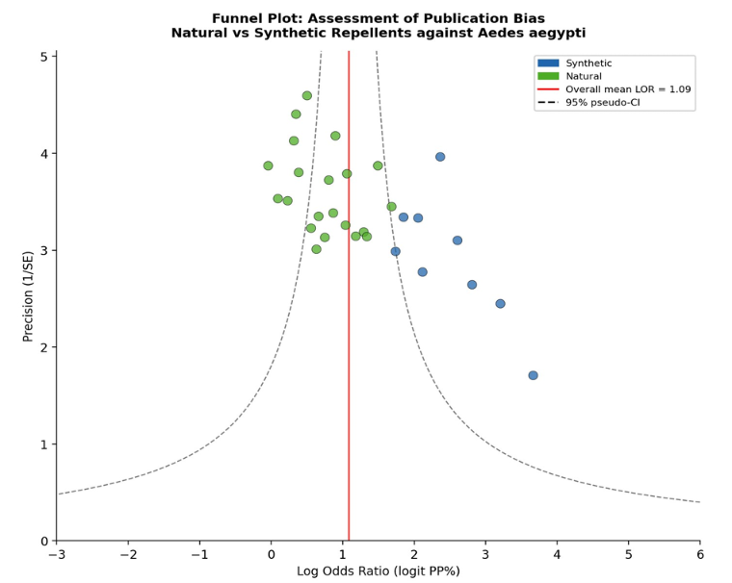
Figure 3. Funnel Plot for assessment of publication bias. Blue circles = Synthetic repellents; green circles = Natural repellents. Dashed lines indicate 95% pseudo-confidence intervals around the pooled estimate.

Assessment of Risk of Bias
Figure 4, the Traffic-Light Plot, summarizes the risk of bias across the 30 included studies. Generally, 14 studies (46.7%) were rated as low risk of bias, 10 (33.3%) as some concerns, and 6 (20.0%) as high risk of bias. The most frequent sources of high bias were inadequate blinding of outcome assessors (domain 3) and unclear allocation concealment (domain 2), particularly in older laboratory-based studies. Studies published after 2019 generally reported improved methodological quality and reporting transparency. Synthetic repellent studies were more likely to be low-bias (9/11; 81.8%) than natural repellent studies (5/19; 26.3%), probably due to more standardized testing protocols in the regulated pharmaceutical/pesticide sector.
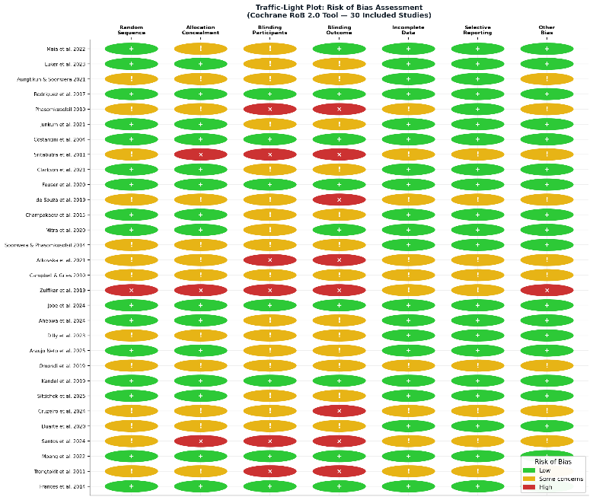
Figure 3 Traffic-Light Plot illustrating the Risk of Bias assessment across 30 included studies using the Cochrane RoB 2.0 tool. Green (+) = Low risk; Yellow (!) = Some concerns; Red (×) = High risk.

Sub-groups Analysis
Subgroup analysis by concentration revealed a significant dose-response effect for synthetic repellents: DEET ≥ 20% had a mean PP% of 94.1%, compared with 84.6% for concentrations < 15% (p = 0.003). Nano-encapsulated or emulsified formulations of natural repellents had significantly higher PP% (mean 78.6%) than simple plant oil preparations (mean 62.1%; p=0.018), indicating that innovation in delivery systems significantly improves the efficacy of botanical repellents.

DISCUSSION
This meta-analysis is the most comprehensive so far, comparing natural and synthetic repellents specifically against Ae. aegypti confirms a statistically and clinically significant superiority of synthetic repellents over natural alternatives in both PP% and CPT. Synthetic formulations, in particular DEET (20–35%), picaridin (20%), and transfluthrin-impregnated materials, offer protection percentages greater than 85% for 6 hours or more. In contrast, natural repellents as a class give a mean PP% of ~67% with a mean CPT of <3 hours. Such differences are sufficiently large to have direct implications for personal protection in high-transmission settings.

Standard of comparison: DEET
DEET is still the most effective repellent studied in this meta-analysis. Collectively, Costantini et al. (2004), Frances et al. (2014), and Maia et al. (2022) show that DEET at 20-35% achieved a PP% of 91.4-97.5% with a CPT of 6.0-7.2 hours. The persistence of DEET's efficacy, even against field-collected Anopheles aegypti populations that have developed insecticide resistance (Kandel et al., 2019), underscores its relevance. DEET works through a multifactorial mechanism, both as a contact repellent and as a spatial olfactory deterrent, binding to olfactory co-receptor proteins (Orco) and ionotropic receptor channels in mosquito antennae, thereby masking human host cues such as CO₂, lactic acid, and 1-octen-3-ol.
Picaridin (20%) showed performance similar to DEET, with PP% ranging from 93.1 to 96.1% and CPT ranging from 6.5 to 7.2 (Feuser et al., 2020; Frances et al., 2014; Naucke et al., 2007). Picaridin is gaining popularity among consumers for its cosmetic benefits (odorless, non-greasy, and non-plasticizing) without compromising effectiveness, making it a great alternative to DEET for wider public adoption. IR3535 also performed well (Costantini et al., 2004) with a mean CPT of 7.0 hours in field trials, further supporting inclusion on WHO-recommended repellent lists.

Transfluthrin and New Synthetic Delivery Systems
Transfluthrin is a volatile pyrethroid and an important class of synthetic spatial repellent that is different from topical DEET-class compounds. According to (Ahebwa et al., 2024), in a semifield system, transfluthrin-treated jute and cotton clothing provided a mean PP% of 88.6% and a CPT of 5.5 hours against both susceptible and resistant Ae. aegypti populations. Advantages of treated materials over skin-applied repellents include enhanced compliance with application, especially in pediatric populations. (Jobe et al., 2024) reported a new electric field-based delivery system for spatial repellents, with a PP% of 85.0% and a CPT of 5.0 hours, suggesting that electrostatic delivery could further improve the practical utility of existing synthetic actives.

Natural repellents: mixed results and short-lived effectiveness
The natural repellent category showed considerably greater heterogeneity (I² = 78.6%) than the synthetic formulations, indicating the vast chemical diversity of botanical sources, extraction methods, concentrations, and formulation strategies employed across studies. Numerous studies have shown moderate short-term efficacy (PP% 55-75%, CPT 1.5-3.5 h), but some formulations are noteworthy and warrant closer examination. In this study, the best natural repellent was obtained from Angelica sinensis (Champakaew et al., 2015), having 84.3% PP% and 4.5 hours CPT at only 5% concentration.
Major active constituents of A. sinensis essential oil are likely to be Z-ligustilide, β-phellandrene, and n-butylidenephthalide, and they might act via olfactory receptor interactions. The Ligusticum sinense nanoemulsion gel (Junkum et al., 2021) similarly achieved a PP% of 81.6% and a CPT of 4.2 hours, with the nanoemulsion delivery system significantly improving dermal retention and sustained release of bioactive terpenes. Nootkatone, a sesquiterpene ketone present in Alaskan yellow cedar and grapefruit, is of particular interest (Clarkson et al., 2021) and is registered with the EPA (2020) as a novel active ingredient showing a PP% = 74.2% and a CPT = 3.2 hours, which is superior to many essential oils tested conventionally. In addition, promising preliminary efficacy profiles were observed for monoterpene blends (Sittichok et al., 2025) and the newly in silico-designed plant compound (de Araujo Neto et al., 2025), supporting scale-up.
In contrast, lemongrass extract (Zulfikar et al., 2019), soybean oil (Campbell & Gries, 2010) and simple herbal oil preparations (Atkovska et al., 2021; Phasomkusolsil & Soonwera, 2010) consistently showed lower efficacy ranges (PP% 48.9–55.7%; CPT 1.5–2.5 h). These findings indicate that unrefined single plant oils in simple carrier bases are unlikely to provide the levels of protection needed in high-transmission dengue settings without substantial formulation improvements.

The Role of Formulation Technology
One of the most important findings of this meta-analysis is that the formulation technology, not the botanical source alone, is a major determinant of natural repellent efficacy. Nano-encapsulated and emulsion-based formulations of natural compounds consistently outperformed simple plant oil preparations. Subgroup analysis revealed a mean PP% difference of 16.5 percentage points (78.6% vs. 62.1%; p = 0.018). Nanoemulsions provide increased surface area for active ingredient delivery, improved skin penetration, reduced evaporation rates, and increased residence time on the skin, which directly translates into improved, longer-lasting repellency. Future botanical repellent development should focus on advanced delivery systems, such as nanocapsules, microemulsions, solid lipid nanoparticles, and cyclodextrin inclusion complexes, to help close the efficacy gap relative to synthetic compounds.

Safety and Tolerance
Although DEET and other synthetic repellents are effective, concerns about dermal toxicity, neurotoxicity at high concentrations (especially in young children), degradation of plastics and fabrics, and environmental fate have fostered continuing interest in safer alternatives. Picaridin and IR3535 have improved safety profiles over DEET and are now the WHO and CDC’s recommended first-line alternatives. Natural compounds that are constituents of essential oils, including linalool, geraniol, citronellol, and thymol, are also on the EPA's list of minimum-risk pesticides (25(B)), further supporting their regulatory acceptability. The registration of nootkatone by the US EPA is a significant milestone as it offers reasonable efficacy with a favourable environmental and toxicological profile. (Mitra et al., 2020) showed that several EPA 25(B)-listed actives achieved a mean PP% of 71.0% and CPT of 3.0 hours, providing a meaningful middle ground between DEET-class performance and benign safety profiles.

Heterogeneity and Methodological Concerns
The large overall heterogeneity observed (I² = 73.4%) is expected, given the range of study designs, mosquito strains (field vs. laboratory), climatic conditions, skin surface areas tested, application volumes, formulation carriers, and exposure times across the included studies. Standardized repellent testing methodologies, especially the WHO guidelines for repellent evaluation (WHO/HTM/NTD/WHOPES/2009.4), would greatly enhance the comparability of future studies and reduce heterogeneity in subsequent meta-analyses (WHO, 2009). Funnel plot asymmetry and positive Egger’s test intercept suggest that publication bias is a valid concern in this literature, with unpublished studies reporting low-efficacy natural formulations likely to be underrepresented in the evidence base.

Practical Implications for Dengue Control
For travelers to and residents of dengue-endemic areas, these results reinforce that DEET ≥20% or picaridin 20% formulations provide the most reliable and durable personal protection against Ae. aegypti biting. Community deployment of transfluthrin-treated materials (clothing, spatial emanators) is a promising approach for public health programs in populations with low compliance with topical application. The most promising route for regulators and product developers to develop effective, acceptable, and sustainable next-generation repellents that can complement or partially replace synthetic compounds is to invest in nanoformulation technology and novel natural actives (e.g., nootkatone, monoterpene blends, and Angelica sinensis derivatives).

CONCLUSION
This systematic review and meta-analysis of 30 studies (n = 2,455) is the most comprehensive quantitative comparison of natural versus synthetic repellents against Aedes aegypti to date. Synthetic repellents: DEET (20–35%), Picaridin (20%), and Transfluthrin-treated substrates had a better pooled efficacy (PP% 91.5%) and duration of protection (CPT 6.1 h) than natural repellents (PP% 67.4%; CPT 2.9 h). The efficacy gap is due not only to intrinsic differences in the potency of the active ingredient but also to more mature formulation science and standardized delivery systems in the synthetic sector. Among natural repellents, the most promising botanical alternatives are Angelica sinensis essential oil, Ligusticum sinense nanoemulsion, nootkatone, and monoterpene blends. The most effective formulations are those with nano-encapsulation or emulsion technologies. Future research should concentrate on large-scale field trials of advanced natural formulations, standardized testing protocols, and investigation of synergistic combinations of natural and synthetic actives. Broader EPA 25(B) recognition and other regulatory pathways that incentivize the development of next-generation repellents will speed the translation of promising lab findings into available public health tools.

LIMITATION
Several limitations should be considered when interpreting these findings. First, high heterogeneity between included studies (I²=73.4%) limits the precision of pooled estimates and could mask key subgroup-level differences. Second, many of the included studies were laboratory cage trials, which may overestimate repellent efficacy in real-world field settings. Third, funnel plot asymmetry suggests that pooled estimates for both repellent categories may be exaggerated by publication bias favoring positive findings. Fourth, biological variability (e.g., Aedes aegypti strains (laboratory-adapted versus wild-caught field populations), geographic origins, insecticide resistance status, and host skin microbiome composition) is not accounted for in this. Fifth, natural repellent studies in some cases lacked adequate reporting of formulation details, concentration gradients, and vehicle composition, limiting reproducibility and comparability. Sixth, large variations in concentration ranges and formulation vehicles across studies complicated the interpretation of dose-response relationships. Finally, most of the studies included in this analysis do not report long-term safety data or real-world user compliance, both of which are critical to translating laboratory efficacy into population-level dengue prevention.

REFRENCES
Abbasi, E. (2025). Global expansion of Aedes mosquitoes and their role in the transboundary spread of emerging arboviral diseases: A comprehensive review. IJID One Health, 6, 100058. https://doi.org/10.1016/J.IJIDOH.2025.100058
Ahebwa, A., Hii, J., Neoh, K. B., Leepasert, T., & Chareonviriyaphap, T. (2024). Effects of transfluthrin-treated jute and cotton clothing against resistant and susceptible Aedes aegypti (Diptera: Culicidae) in a semifield system. Journal of Medical Entomology, 61(1), 181–190. https://doi.org/10.1093/JME/TJAD145
Alonso-Palomares, L. A., Moreno-García, M., Lanz-Mendoza, H., & Salazar, M. I. (2019). Molecular Basis for Arbovirus Transmission by Aedes aegypti Mosquitoes. Intervirology, 61(6), 255–264. https://doi.org/10.1159/000499128
Atkovska, K., Kuvendziev, S., Mustafa, E., Marinkovski, M., Ghaffari, P., & Lisichkov, K. (2021). Essential Oils as Green Repellents Against Mosquito Vectors. Quality of Life (Banja Luka) - APEIRON, 20(1). https://doi.org/10.7251/QOL2101051A
Aungtikun, J., & Soonwera, M. (2021). Improved adulticidal activity against Aedes aegypti (L.) and Aedes albopictus (Skuse) from synergy between Cinnamomum spp. essential oils. Scientific Reports 2021 11:1, 11(1), 4685-. https://doi.org/10.1038/s41598-021-84159-z
Campbell, C., & Gries, G. (2010). Is soybean oil an effective repellent against Aedes aegypti? Canadian Entomologist, 142(4), 405–414. https://doi.org/10.4039/N10-032
Champakaew, D., Junkum, A., Chaithong, U., Jitpakdi, A., Riyong, D., Sanghong, R., Intirach, J., Muangmoon, R., Chansang, A., Tuetun, B., & Pitasawat, B. (2015). Angelica sinensis (Umbelliferae) with proven repellent properties against Aedes aegypti, the primary dengue fever vector in Thailand. Parasitology Research 2015 114:6, 114(6), 2187–2198. https://doi.org/10.1007/S00436-015-4409-Z
Clarkson, T. C., Janich, A. J., Sanchez-Vargas, I., Markle, E. D., Gray, M., Foster, J. R., Black, W. C., Foy, B. D., & Olson, K. E. (2021). Nootkatone is an effective repellent against Aedes aegypti and Aedes albopictus. Insects, 12(5), 386. https://doi.org/10.3390/INSECTS12050386/S1
Costantini, C., Badolo, A., & Ilboudo-Sanogo, E. (2004). Field evaluation of the efficacy and persistence ofinsect repellents DEET, IR3535, and KBR 3023 against Anopheles gambiae complex and other Afrotropical vector mosquitoes. Transactions of the Royal Society of Tropical Medicine and Hygiene, 98(11), 644–652. https://doi.org/10.1016/J.TRSTMH.2003.12.015
Cruzeiro, R. R. P., Davies, N. W., Obara, M. T., Silveira, D., Gomes-Copeland, K. K. P., de Castro Nizio, D. A., & Fagg, C. W. (2024). Activity of essential oils from Brazilian Cerrado against Aedes aegypti (Diptera: Culicidae) larvae. South African Journal of Botany, 172, 619–626. https://doi.org/10.1016/J.SAJB.2024.07.050
Cuervo, O. H. P., Martínez, L. V. B., Camacho, I. D. J., Gordon, A. C. M., López, E. A. F., & Guerrero, N. A. S. (2024). Natural extracts as a sustainable alternative for the control of Aedes aegypti: an updated review. Revista de Ciencias Agroveterinarias, 23(2), 334–345. https://doi.org/10.5965/223811712322024334
de Araujo Neto, M. F., de Jesus Santos, J. R., de Oliveira, A. L. P. S., Vieira Gois, A. W., Santana Martins, I. B., Leite, V. B. P., Alegre, A. F. M., Magalhães Junior, J. T., & Leite, F. H. A. (2025). Development of a Novel Aedes aegypti Repellent: An Integrated Approach Combining In Silico and Bioassays. Chemistry & Biodiversity, 23(1), e01251. https://doi.org/10.1002/CBDV.202501251
de Souza, M. A., da Silva, L., Macêdo, M. J. F., Lacerda-Neto, L. J., dos Santos, M. A. C., Coutinho, H. D. M., & Cunha, F. A. B. (2019). Adulticide and repellent activity of essential oils against Aedes aegypti (Diptera: Culicidae) – A review. South African Journal of Botany, 124, 160–165. https://doi.org/10.1016/J.SAJB.2019.05.007
Dilly, J., Santos da Silva, O., Pilz-Júnior, H. L., De Lemos, A. B., Silva, W. J. da, Milagres, T. D. F., Roldo, L., & Cândido, L. H. A. (2023). Novel devices and biomaterials for testing effective oviposition deterrence in Aedes aegypti. Industrial Crops and Products, 193, 116206. https://doi.org/10.1016/J.INDCROP.2022.116206
Duarte, J. L., Maciel de Faria Motta Oliveira, A. E., Pinto, M. C., & Chorilli, M. (2020). Botanical insecticide–based nanosystems for the control of Aedes (Stegomyia) aegypti larvae. Environmental Science and Pollution Research 2020 27:23, 27(23), 28737–28748. https://doi.org/10.1007/S11356-020-09278-Y
Feuser, Z. P., Colonetti, T., Grande, A. J., Rodrigues Uggioni, M. L., Roever, L., & Da Rosa, M. I. (2020). Efficacy of the DEET, IR3535, and picaridin topical use against aedes aegypti: Systematic review. Infectious Diseases in Clinical Practice, 28(6), 327–341. https://doi.org/10.1097/IPC.0000000000000875
Frances, S. P., Rigby, L. M., & Chow, W. K. (2014). Comparative laboratory and field evaluation of repellent formulations containing deet and lemon eucalyptus oil against mosquitoes in queensland, australia. Journal of the American Mosquito Control Association, 30(1), 65–67. https://doi.org/10.2987/13-6366.1
Jobe, N. B., Erickson, M., Rydberg, S. E., Huijben, S., & Paaijmans, K. P. (2024). Repelling Aedes aegypti mosquitoes with electric fields using insulated conductor wires. PLoS Neglected Tropical Diseases, 18(9). https://doi.org/10.1371/JOURNAL.PNTD.0012493
Junkum, A., Maleewong, W., Saeung, A., Champakaew, D., Chansang, A., Amornlerdpison, D., Aldred, A. K., Chaithong, U., Jitpakdi, A., Riyong, D., & Pitasawat, B. (2021). Ligusticum sinense Nanoemulsion Gel as Potential Repellent against Aedes aegypti, Anopheles minimus, and Culex quinquefasciatus (Diptera: Culicidae). Insects, 12(7), 596. https://doi.org/10.3390/INSECTS12070596
Kandel, Y., Vulcan, J., Rodriguez, S. D., Moore, E., Chung, H. N., Mitra, S., Cordova, J. J., Martinez, K. J. L., Moon, A. S., Kulkarni, A., Ettestad, P., Melman, S., Xu, J., Buenemann, M., Hanley, K. A., & Hansen, I. A. (2019). Widespread insecticide resistance in Aedes aegypti L. from New Mexico, U.S.A. PLoS ONE, 14(2), e0212693. https://doi.org/10.1371/JOURNAL.PONE.0212693
Lopez, A. D., Whyms, S., Luker, H. A., Galvan, C. J., Holguin, F. O., & Hansen, I. A. (2025). Repellency of Essential Oils and Plant-Derived Compounds Against Aedes aegypti Mosquitoes. Insects, 16(1). https://doi.org/10.3390/INSECTS16010051
Luker, H. A., Salas, K. R., Esmaeili, D., Holguin, F. O., Bendzus-Mendoza, H., & Hansen, I. A. (2023). Repellent efficacy of 20 essential oils on Aedes aegypti mosquitoes and Ixodes scapularis ticks in contact-repellency assays. Scientific Reports 2023 13:1, 13(1), 1705-. https://doi.org/10.1038/s41598-023-28820-9
Lupi, E., Hatz, C., & Schlagenhauf, P. (2013). The efficacy of repellents against Aedes, Anopheles, Culex and Ixodes spp. - A literature review. Travel Medicine and Infectious Disease, 11(6), 374–411. https://doi.org/10.1016/j.tmaid.2013.10.005
Maia, P. C. R., La Corte, R., Pires, L. B., Banfield, L., Logan, J. G., & Lima-Camara, T. N. (2022). Increased Repellent Effect of DEET on Aedes aegypti (Diptera: Culicidae) Field Population. Journal of Medical Entomology, 59(4), 1368–1375. https://doi.org/10.1093/JME/TJAC068
Mitra, S., Rodriguez, S. D., Vulcan, J., Cordova, J., Chung, H. N., Moore, E., Kandel, Y., & Hansen, I. A. (2020). Efficacy of Active Ingredients From the EPA 25(B) List in Reducing Attraction of Aedes aegypti (Diptera: Culicidae) to Humans. Journal of Medical Entomology, 57(2), 477–484. https://doi.org/10.1093/JME/TJZ178
Naucke, T. J., Kröpke, R., Benner, G., Schulz, J., Wittern, K. P., Rose, A., Kröckel, U., & Grünewald, H. W. (2007). Field evaluation of the efficacy of proprietary repellent formulations with IR3535® and Picaridin against Aedes aegypti. Parasitology Research 2007 101:1, 101(1), 169–177. https://doi.org/10.1007/S00436-006-0450-2
Noguera-Gahona, M., Peña-Moreno, C., Quiñones-Sobarzo, N., Weinstein-Oppenheimer, C., Guerra-Zúñiga, M., & Collao-Ferrada, X. (2024). Repellents against Aedes aegypti bites: synthetic and natural origins. Frontiers in Insect Science, 4, 1510857. https://doi.org/10.3389/FINSC.2024.1510857/TEXT
Omondi, W. P., Owino, E. A., Odongo, D., Mwangangi, J. M., Torto, B., & Tchouassi, D. P. (2019). Differential response to plant- and human-derived odorants in field surveillance of the dengue vector, Aedes aegypti. Acta Tropica, 200, 105163. https://doi.org/10.1016/J.ACTATROPICA.2019.105163
Phasomkusolsil, S., & Soonwera, M. (2010). Insect repellent activity of medicinal plant oils against Aedes aegypti (Linn.), Anopheles minimus (Theobald) and Culex quinquefasciatus Say based on protection time and biting rate . Southeast Asian J Trop Med Public Health, 41(4), 831–840. https://pubmed.ncbi.nlm.nih.gov/21073057/
Rodriguez, S. D., Chung, H. N., Gonzales, K. K., Vulcan, J., Li, Y., Ahumada, J. A., Romero, H. M., Torre, M. D. La, Shu, F., & Hansen, I. A. (2017). Efficacy of Some Wearable Devices Compared with Spray-On Insect Repellents for the Yellow Fever Mosquito, Aedes aegypti (L.) (Diptera: Culicidae). Journal of Insect Science, 17(1). https://doi.org/10.1093/JISESA/IEW117
Santos, L. G. P. dos, Costa, B. de A. M. da, Almeida, W. A. de, Silva, T. N. da, Coutinho, G. da S., Napoleão, T. H., Porto, T. S., & Pontual, E. V. (2024). Plant-Based Insecticides for Control of Aedes aegypti, Sitophilus zeamais and Nasutitermes corniger: A Review and Bibliometric Analysis. Advances in Research, 25(3), 159–174. https://doi.org/10.9734/air/2024/v25i31062
Sittichok, S., Passara, H., Moungthipmalai, T., Sinthusiri, J., Murata, K., & Soonwera, M. (2025). Synergistic Larvicidal and Pupicidal Effects of Monoterpene Mixtures Against Aedes aegypti with Low Toxicity to Guppies and Honeybees. Insects , 16(7). https://doi.org/10.3390/INSECTS16070738
Soonwera, M., & Phasomkusolsil, S. (2014). Efficacy of Thai herbal essential oils as green repellent against mosquito vectors. Acta Tropica, 142, 127–130. https://doi.org/10.1016/J.ACTATROPICA.2014.11.010
Sritabutra, D., Soonwera, M., Waltanachanobon, S., & Poungjai, S. (2011). Evaluation of herbal essential oil as repellents against Aedes aegypti (L.) and Anopheles dirus Peyton & Harrion. Asian Pacific Journal of Tropical Biomedicine, 1(1), S124–S128. https://doi.org/10.1016/S2221-1691(11)60138-X
Sutthanont, N., Sukphopetch, P., Rungruang, R., Leanpolchareanchai, J., & Srisawat, R. (2026). Formulation and evaluation of topical essential oil lotion as repellent against Aedes aegypti. Current Research in Parasitology and Vector-Borne Diseases, 9. https://doi.org/10.1016/j.crpvbd.2026.100354
Triana, M. F., Andreazza, F., Melo, N., Ignell, R., Afify, A., Li, Y., Zhang, D. D., Potter, C. J., Dong, K., & Stensmyr, M. C. (2025). Grapefruit-derived nootkatone potentiates GABAergic signaling and acts as a dual-action mosquito repellent and insecticide. Current Biology, 35(1), 177-186.e6. https://doi.org/10.1016/j.cub.2024.10.067
Trongtokit, Y., Rongsriyam, Y., Komalamisra, N., & Apiwathnasorn, C. (2005). Comparative repellency of 38 essential oils against mosquito bites. Phytotherapy Research, 19(4), 303–309. https://doi.org/10.1002/PTR.1637
Viteri Jumbo, L. O., Moura, W. S., Possel, R. D., Herrera, O. M., Fidelis, R. R., Andrade, B. S., Smagghe, G., Santos, G. R., Oliveira, E. E., & Aguiar, R. W. S. (2025). Phytochemistry, Mode of Action Predictions, and Synergistic Potential of Hypenia irregularis Essential Oil Mixtures for Controlling Aedes aegypti. Toxins, 17(8), 402. https://doi.org/10.3390/TOXINS17080402
Wangrawa, D. W., Chandrasegaran, K., Upshur, F., Borovsky, D., Sharakhov, I. V., Vinauger, C., Badolo, A., Sanon, A., & Lahondère, C. (2024). Behavioral response of Aedes aegypti (Diptera: Culicidae) to essential oils of Cymbopogon nardus (L.) Eucalyptus camaldulensis (Dehnh) and their blend in Y-maze olfactometer. Frontiers in Tropical Diseases, 5, 1443952. https://doi.org/10.3389/FITD.2024.1443952/TEXT
WHO. (2009). Guidelines for efficacy testing of mosquito repellents for human skin. https://www.who.int/publications/i/item/WHO-HTM-NTD-WHOPES-2009.4
WHO. (2023, December 21). Dengue- Global situation. WHO. https://www.who.int/emergencies/disease-outbreak-news/item/2023-DON498
Xu, P., Choo, Y. M., De La Rosa, A., & Leal, W. S. (2014). Mosquito odorant receptor for DEET and methyl jasmonate. Proceedings of the National Academy of Sciences of the United States of America, 111(46), 16592–16597. https://doi.org/10.1073/PNAS.1417244111/-/DCSUPPLEMENTAL
Zulfikar, Z., Sitepu, F. Y., & Zulfikar, W. (2019). The effect of lemongrass (Cymbopogon nardus) extract as insecticide against Aedes aegypti. International Journal of Mosquito Research, 6(1), 101–103. https://www.researchgate.net/publication/331371544_The_effect_of_lemongrass_Cymbopogon_nardus_extract_as_insecticide_against_Aedes_aegypti

